Dylan Nelson
CSA322: Complex Online Investigation
Mr. Zambotti
September 27, 2026
OSINT Dojo’s Sakura Room Report
Executive Summary:
The purpose of this report is to complete and document the OSINT Dojo’s Sakura room. The room tests a variety of different OSINT techniques and can be completed by beginners. The room is a simulated cyber-attack conducted by an attacker that left behind an image. Analysis of the attacker’s image and source code provide the alias “SakuraSnowAngelAiko,” which is linked to GitHub and X accounts. Further investigation reveals the attacker’s email address, real name, Ethereum wallet address, mining pools, and use of Tether.

Additional Analysis on the attacker’s social media to place them at various locations such as Ronald Regan Washington National Airport and Haneda Airport. On top of that, analyzing the attacker’s Wi-Fi SSID and BSSID can be done to place them in Hirosaki. Overall, the information found can be used to identify the attacker’s online and personal identity, cryptocurrency activity, travel activity, and a likely home city.

Tip-Off:
The room starts with the story of a recent cyber-attack. The attacker left behind an image to inspect and find the username that the attacker goes by. Opening the file, the message "you have been pwned!" can be seen with zeroes and ones behind it (Figure 1.1). These could likely be a message hidden in binary. Using the AI model GPT-5.6 Luna, it converted the binary in the image to text, and the output was, "A picture is worth a thousand words." This alone does not give us information on the attacker's username, so further investigation is required.
Using Inspect Element, the code used to create the image is visible. After reviewing the background code, the file path for the user's computer can be seen. The name shown is "SakuraSnowAngelAiko" (Figure 1.2). This username is what the attacker goes by and allows for further investigation.
Figure 1.1:

Figure 1.2:
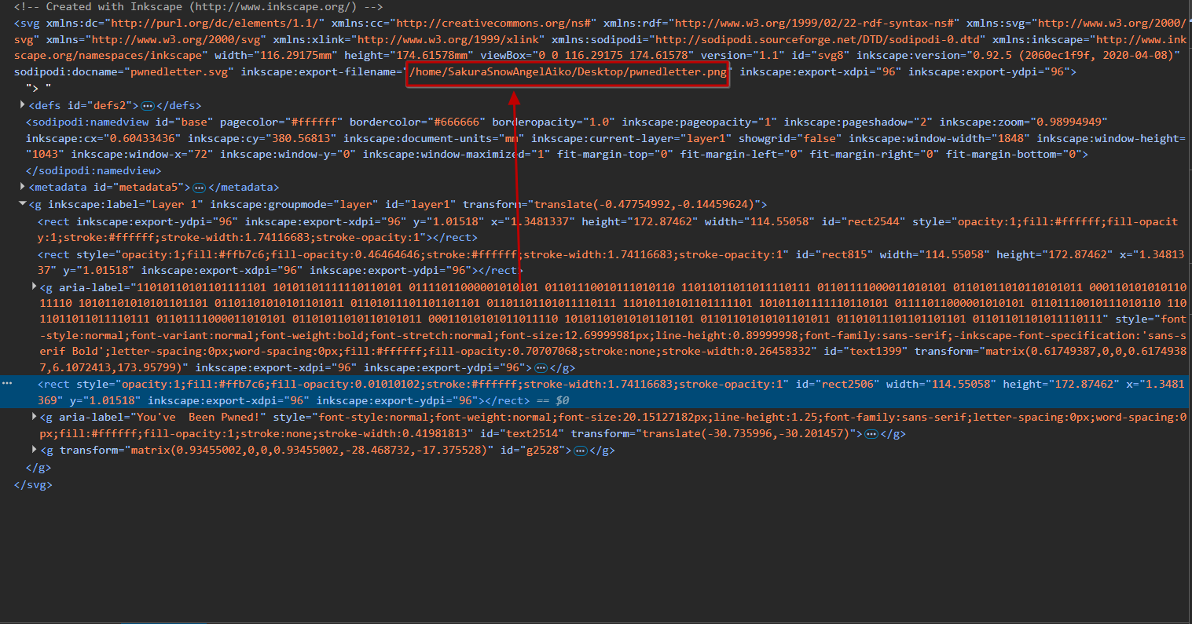

Reconnaissance:
With the attacker's username, "SakuraSnowAngelAiko," a simple Google search yields a GitHub repository under that name, as well as an X account with the username "@SakuraLoverAiko". The next flag is the attacker's email address. Searching through all the repositories on GitHub, a PGP key can be found (Figure 2.1). Using a public PGP key reader, the email address "SakuraSnowAngel83@protonmail.com" is provided (Figure 2.2). Moving over to the attacker's X account, one of their post’s points to another related X account by the name of "@AikoAbe3". This post on the account grants the attacker's real name, Aiko Abe, which is the next required flag (Figure 2.3).

Figure 2.1:
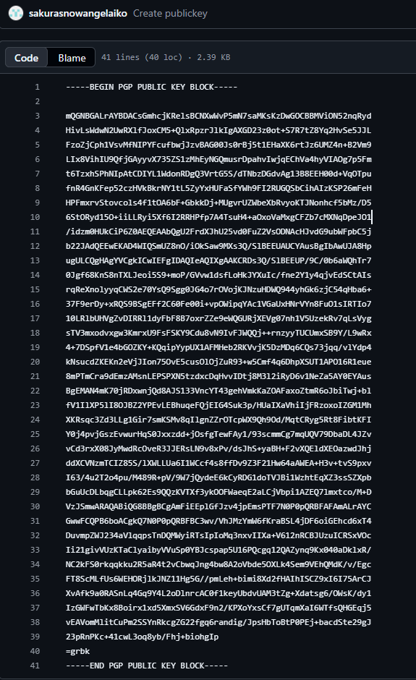
Figure 2.2:
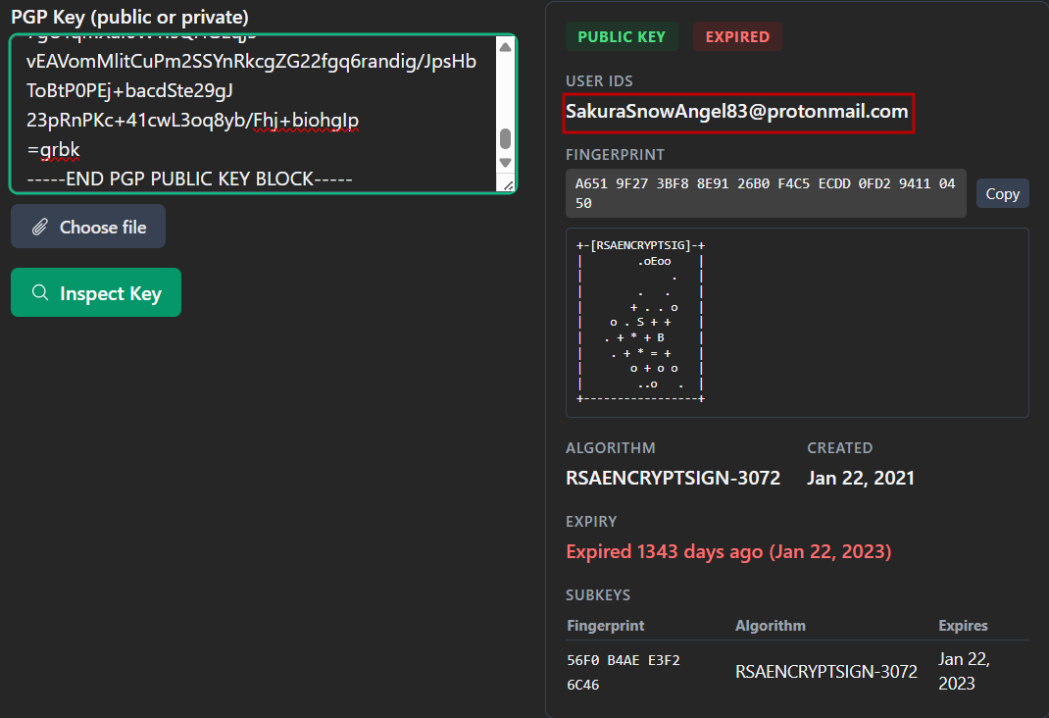

Figure 2.3:
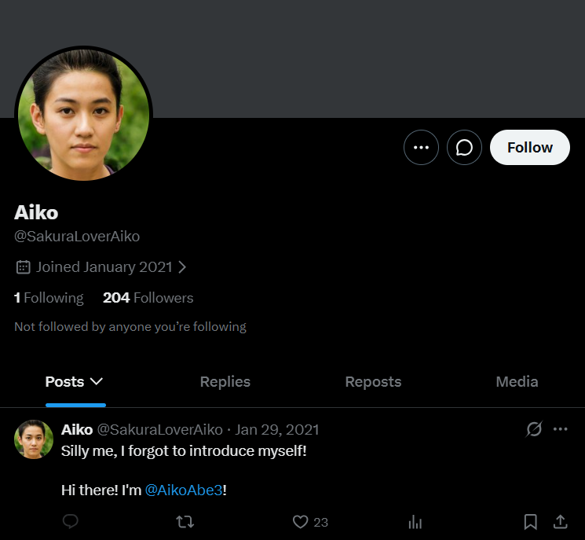

Unveil:
The next step is to find a variety of information regarding the attacker’s cryptocurrency wallet, address, and transactions made. Searching through the X account, no information regarding cryptocurrency can be found. Moving back to the GitHub repositories, upon further review on the attackers "commits" on GitHub, there are 2 specific "commits" made to the "miningscript" repository on January 23, 2021. These "commits" provide the wallet address "0xa102397dbeeBeFD8cD2F73A89122fCdB53abB6ef", which can also be used to identify the crypto wallet as an Ethereum wallet (Figure 3.1, Figure 3.2).
Further investigation of the attacker's crypto wallet is needed to identify the mining pool they received payment from on January 23, 2021, as well as other cryptocurrencies they exchanged. Using a blockchain explorer, the payment can be found on that date, and the payment was received from "Ethermine" (Figure 3.3). Further investigation of the blockchain explorer shows another cryptocurrency, “Tether,” being exchanged, which is the final flag for this portion (Figure 3.4).
Figure 3.1:
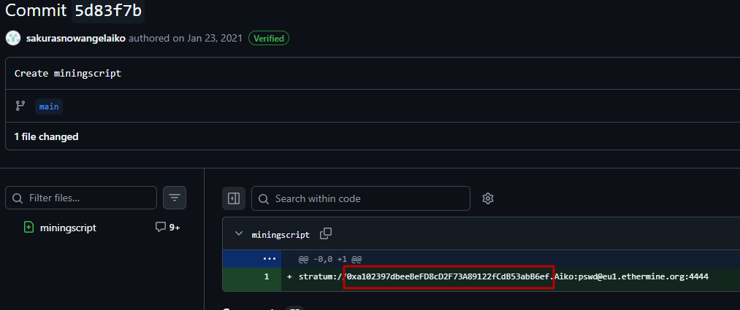
Figure 3.2:
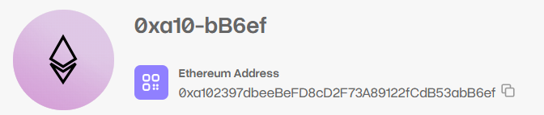

Figure 3.3:
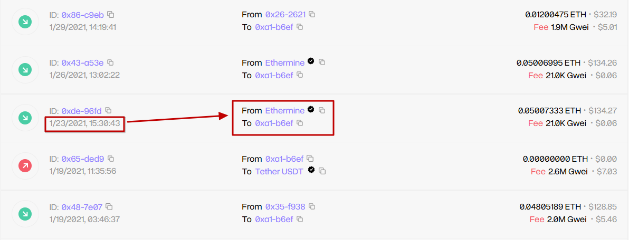
Figure 3.4:
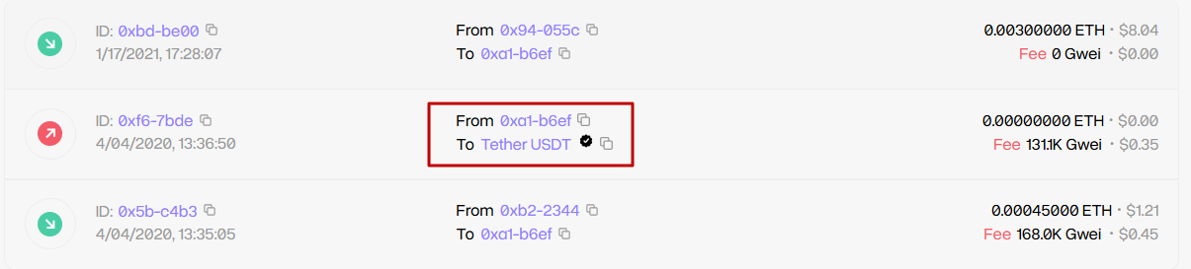

Taunt:
The next flag was to get the attacker's current "Twitter" or X handle. This information is already known to be “@SakuraLoverAiko" from the account found previously. To further confirm this suspicion, the photo provided of the message from the account proves this is the attacker (Figure 4.1). This is proven because the photos on the accounts are the same, and both lead to the other X account, "@AikoAbe3" (Figure 2.3).
The flag after this is to find the attacker's BSSID; however, an alternative method had to be used for this portion of the room because the intended way is no longer available. The intended method is to use the onion site "Deep Paste" to find the attacker's home Wi-Fi SSID and use that to find the BSSID. Due to the "Deep Paste" onion site being unreachable, the SSID can still be obtained in various ways. The SSID was obtained through https://1d8.github.io/writeups/thm/sakurathmosint/, another Sakura room writeup that had a screenshot of the intended SSID (Figure 4.2). Using the SSID "DF1K-G" on the site wigle.net, it provides the attackers BSSID of "84:af:ec:34:fc:f8" (Figure 4.3).
Figure 4.1:
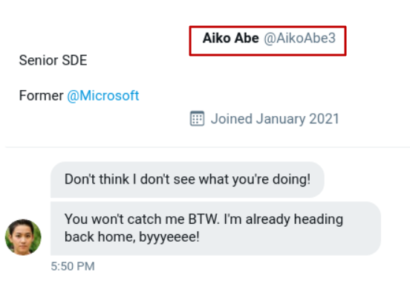

Figure 4.2:
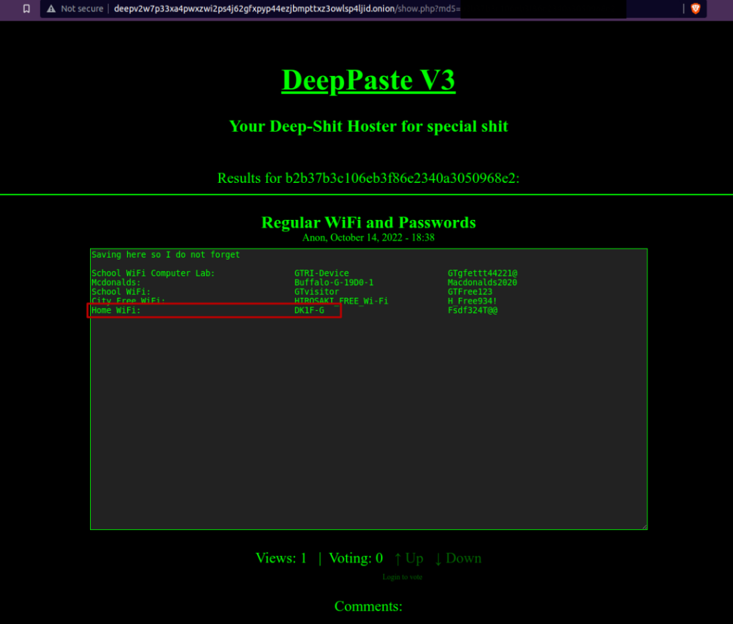
Figure 4.3:
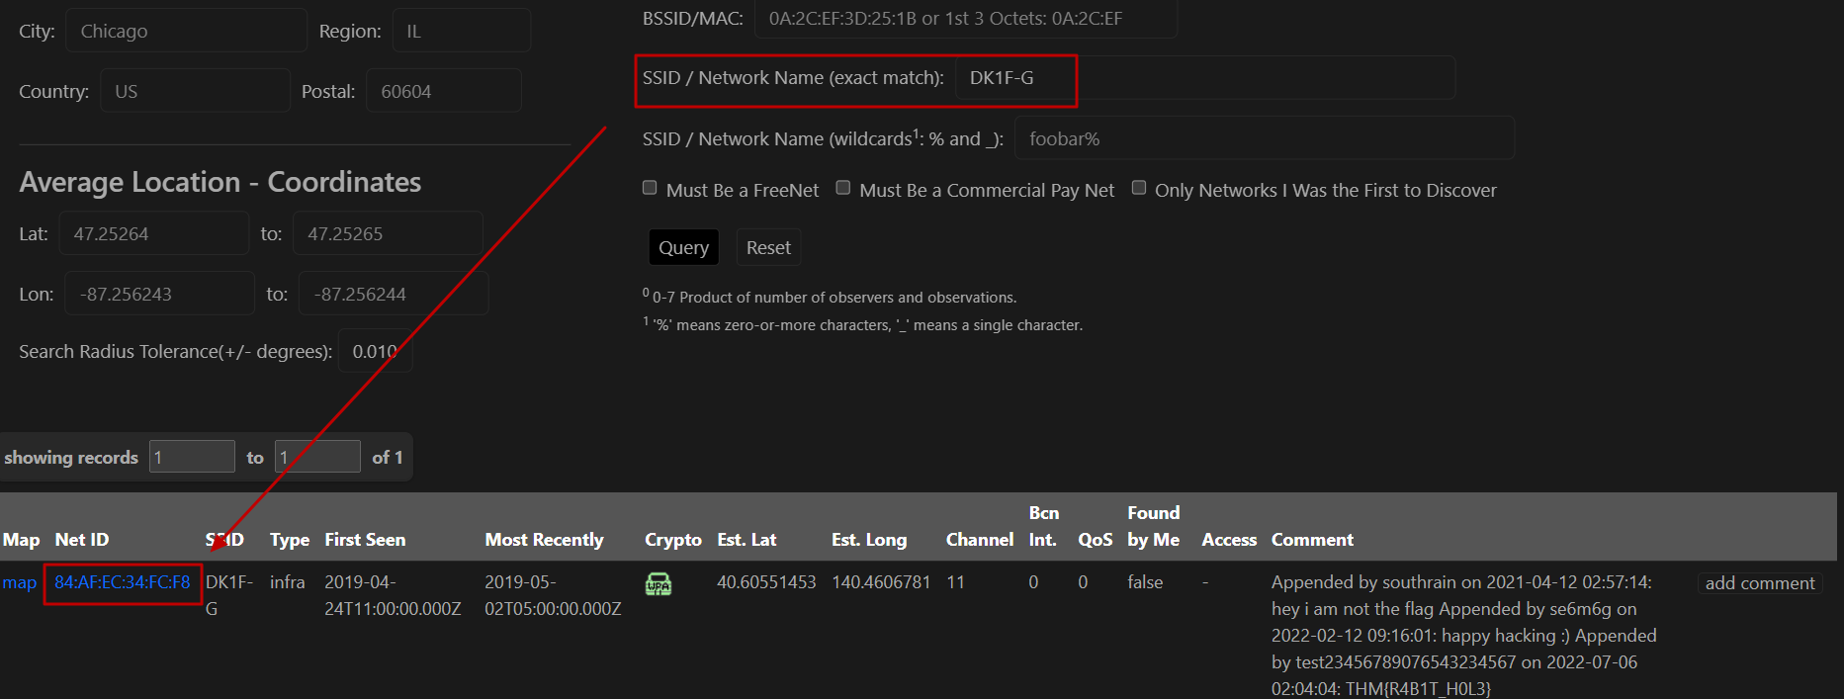

Homebound:
The final portion of this room is to find a series of locations that the attacker has posted and where they likely consider "home". The first requirement is to find the airport closest to where the attacker shared a photo before their flight. In the photo captioned "Checking out some last minute cherry blossoms before heading home!", the Washington Monument is visible in the background (Figure 5.1). Using this information, conducting a simple Google search for the airport closest to the Washington Monument will provide the result Ronald Reagan Washington National Airport (DCA). This information is also useful for the next flag because finding the location of the attacker’s layover is required. In the photo captioned "My final layover, time to relax!" a sign with JAL Sakura Lounge is visible (Figure 5.2). Using this, searching for flights from DCA to JAL, most flights go through Haneda (HND) and Narita (NRT) airports. Upon further research, it is determined that Haneda Airport is the correct one because it is the main JAL airport, while Narita is mainly used for "intercontinental destinations with Asian destinations."
The next flag requires the name of the lake that is visible in the photo on the attacker’s X account from their final flight home. On the post captioned "Sooo close to home! Can't wait to finally be back! :)," a map can be seen with several identifiers (Figure 5.3). Using Google Maps, identifying the lake is as simple as matching the location in the photo to somewhere in Japan. The easiest identifier is the island on the left side of the photo; simply find the general area on the map, locate the island, and look around until the lake is visible (Figure 5.4). On Google Maps, just hovering over a location provides the name, which reads Lake Inawashiro (Figure 5.5).
The final flag requires the city that the attacker most likely considers "home". Using the BSSID information provided on wigle.net, click on the map link, and it will pull up an interactive map. On the interactive map, it has a marker with the location of Hirosaki (Figure 5.6). This is where the attacker likely considers home, as their home Wi-Fi BSSID points to that location.
Figure 5.1:
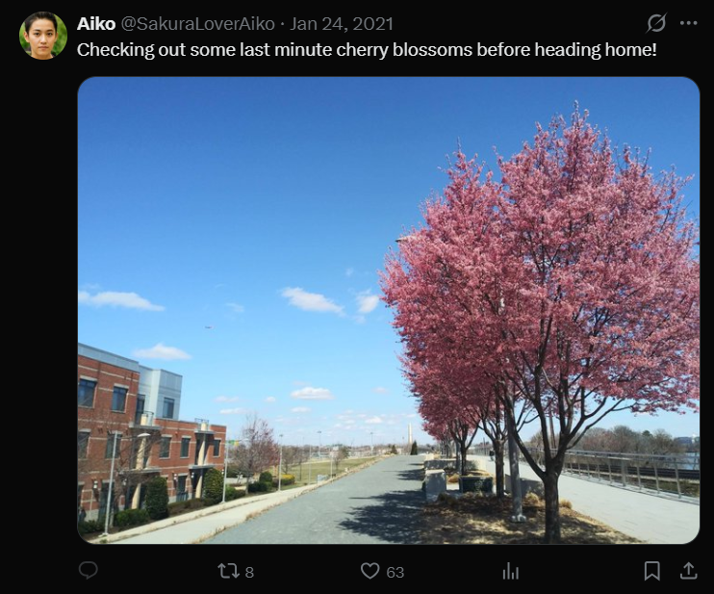

Figure 5.2:
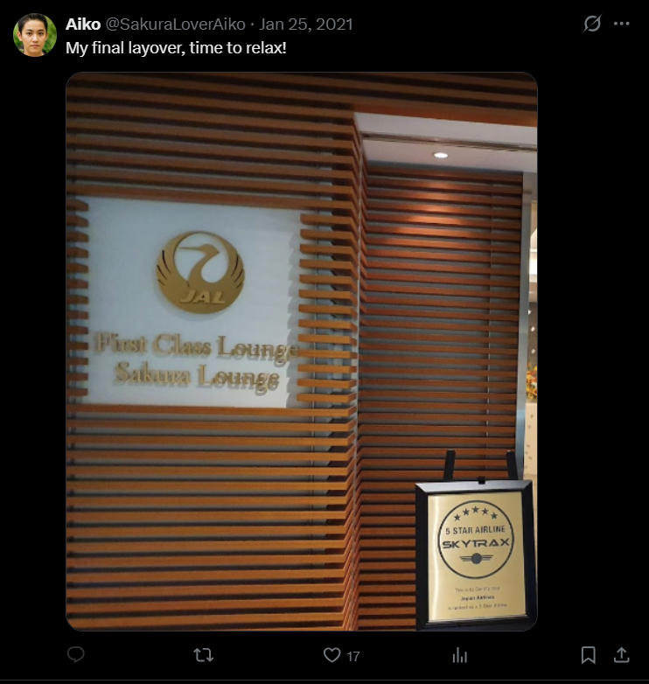
Figure 5.3:
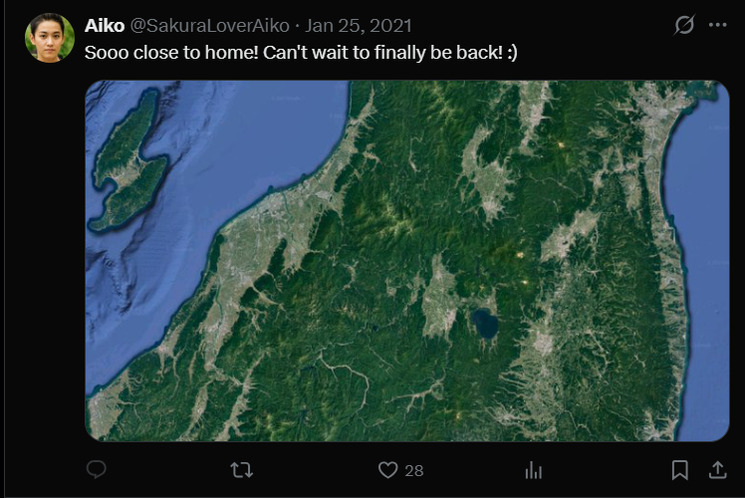

Figure 5.4:
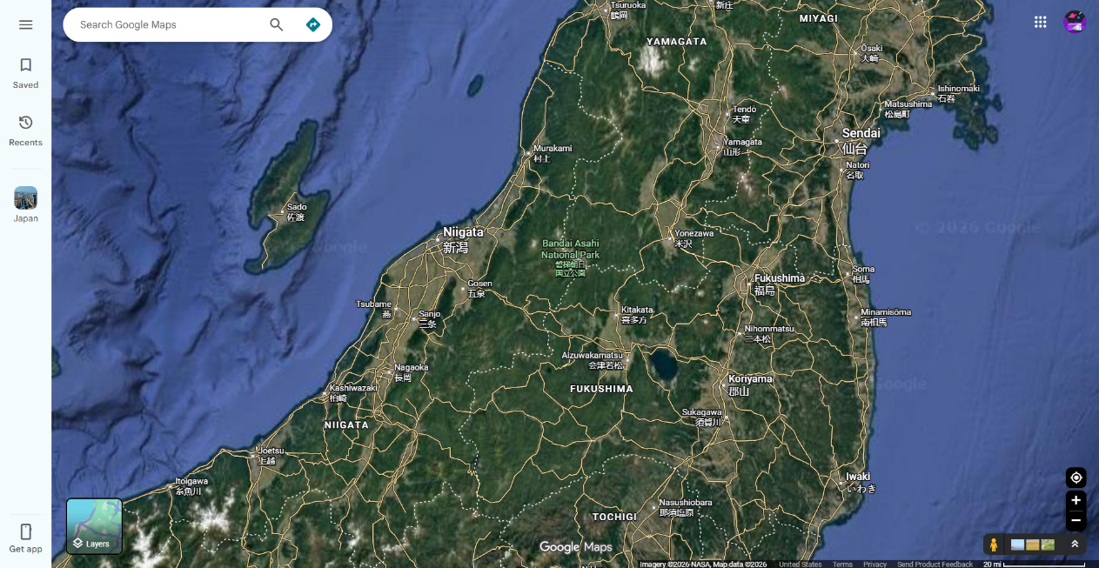
Figure 5.5:
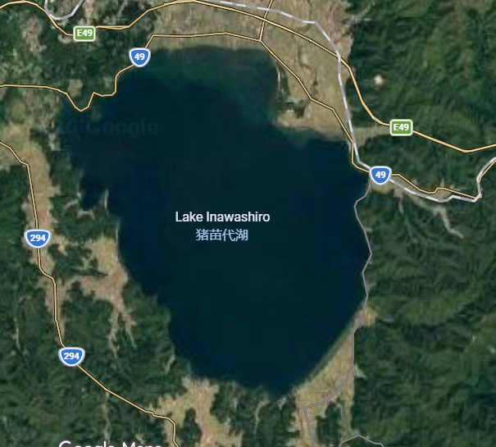

Figure 5.6:
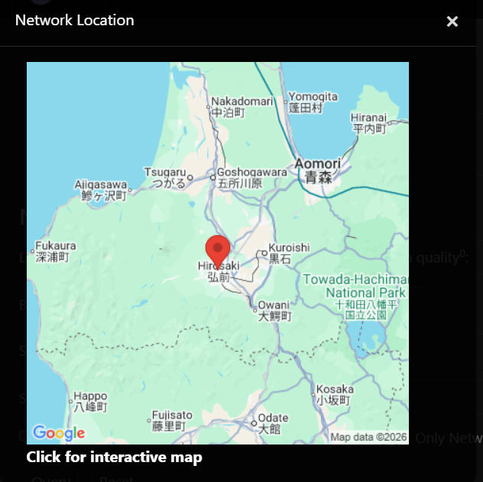
Conclusion:
After completing the OSINT Dojo’s Sakura room, it does a great job testing different beginner OSINT techniques and how to build an attacker’s identity. The room requires in depth analysis of source code, online accounts, public repositories, cryptocurrency transactions, wireless network data, and travel posts that helped identify the attacker’s email address, real name, X handle, crypto wallet address, and a probable home location. Overall, this shows how publicly available information can be used to identify a person’s online activity, financial activity, and likely where they live.

